8800 Roswell Road, Suite A235
Sandy Springs, GA 30350
Phone: 770.641.9797
Fax: 770:641.9771
Email: candace@alternahealthsolutions.com

PATIENT INTAKE
Nutrition Response Testing
Please print clearly

Date:

Patient Full Legal Name: Preferred Name: Maiden Name:
Date of Birth: Age: Gender: F / M Marital Status: Single / Married / Divorced
Street Address:
City: State: Zip: Email:
Cell Phone: Home Phone: Work Phone: Primary: HM / WK / Cell
Referred by:
Employer: SSN:
Employment: ( ) Employed ( ) F / T Student ( ) P/T Student ( ) Retired
Spouse’s Name: Children’s Names and Ages:
In emergency, contact: Phone: Relationship:

Overall health (circle one): Excellent / Good / Fair / Poor / Other:

Chief complaint (reason you are here): (use separate sheet if more room needed)

Previous treatments for this complaint
Other complaints or problems: (use separate sheet if needed)
Current medications/drugs being taken: (use separate sheet if needed)
Are you currently under the care of a physician or other health care professionals? (If yes, please give name and date of last visit):

Nutritional supplements you are taking:

Do you smoke, drink coffee, or drink alcohol? (If yes, indicate how much) Cigarettes ______________ Coffee ______________ Alcohol ________________

Office Use Only:

Date:

Name:
HISTORY:
List any major illnesses (with approx. dates):

List any surgery or operations with approx. date:

Past Accidents or injuries:

Marital Status: S M D W Name of Spouse:
Describe health of spouse: Number of children, if any:
Name of Child Age Sex Any physical conditions or concerns?
M / F M / F M / F M / F
Any family history of serious illnesses (circle those which apply): Cancer / Diabetes / Heart / Other
Any household pets or other animals you or family members are in close contact with:
What can we do to make you happier?

SIGNED: DATE:

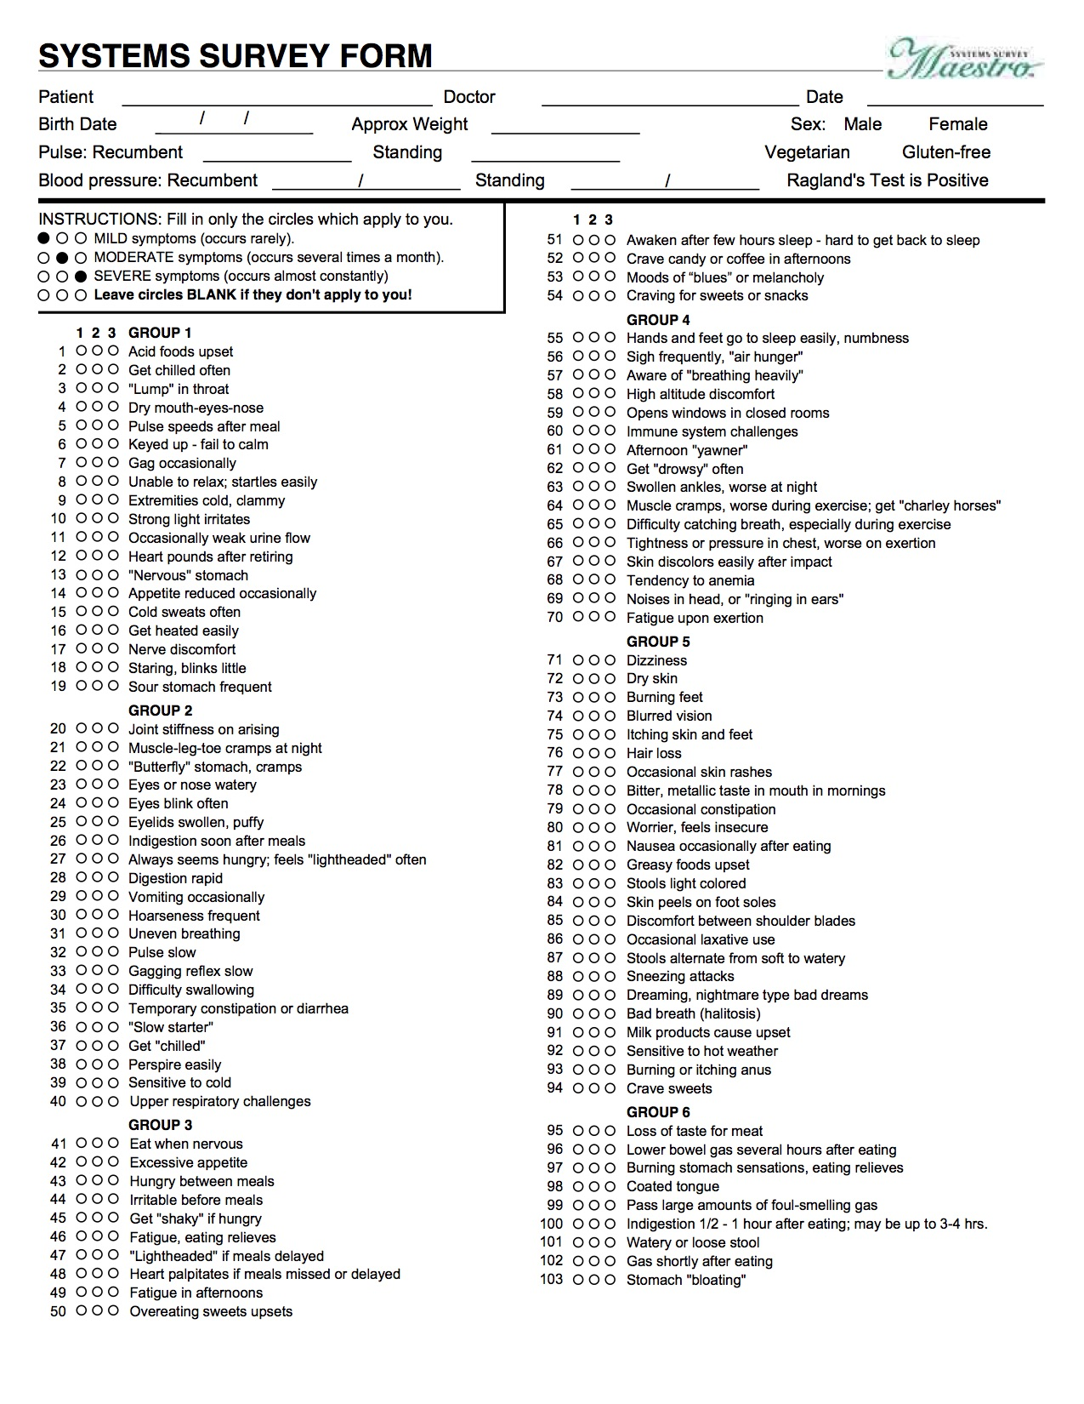

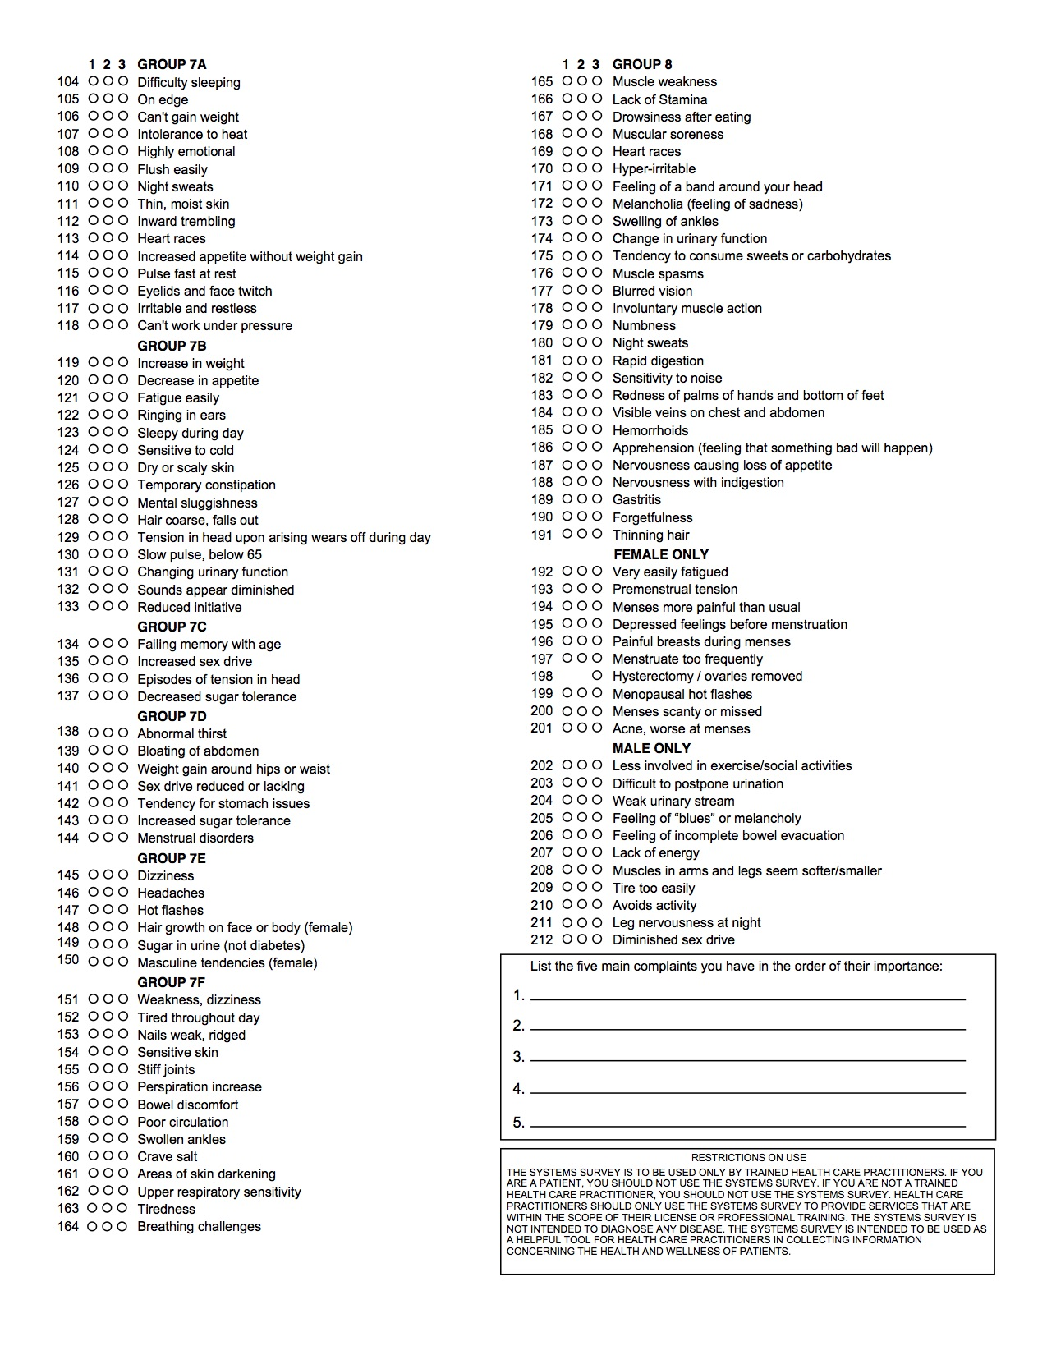

PERMISSION & AUTHORIZATION FORM
REGARDING USE OF
NUTRITION RESPONSE TESTING™

PLEASE READ BEFORE SIGNING:

I specifically authorize the natural health practitioners at AlternaHealth Solutions to perform a Nutrition Response Testing health analysis and to develop a natural, complementary health improvement program for me which may include dietary guidelines, nutritional supplements, etc. in order to assist me in improving my health, and not for the treatment, or “cure” of any disease.

I understand that Nutrition Response Testing is a safe, non-invasive, natural method of analyzing the body’s physical and nutritional needs, and that deficiencies or imbalance in these areas could cause or contribute to various health problems.

I understand that Nutrition Response Testing is not a method for “diagnosing” or “treating” of any disease including conditions of cancer, AIDS, infections, or other medical conditions, and that these are not being tested for or treated.

No promise or guarantee has been made regarding the results of Nutrition Response Testing or any natural health, nutritional or dietary programs recommended, but rather I understand that Nutrition Response Testing is a means by which the body’s natural reflexes can be used as an aid to determining possible nutritional imbalances, so that safe natural programs can be developed for the purpose of bring about a more optimum state of health.

I have read and understand the foregoing.

This permission form applies to subsequent visits and consultations.

Date:

Print Name:

Signature:

(If minor, signature of parent or guardian required)

Witness: Date:

